5.37: a) The magnitude of the normal force is 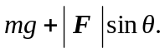 The horizontal component of 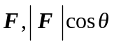 must balance the frictional force, so
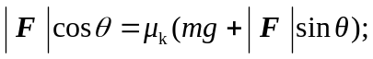
solving for  gives
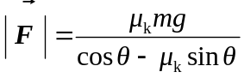
b) If the crate remains at rest, the above expression, with 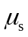 instead of 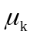, gives the force that must be applied in order to start the crate moving. If 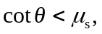 the needed force is infinite, and so the critical value is 